**What is Monolithic Architecture?**

Monolithic architecture is a software design methodology that combines all of an application's components into a single, inseparable unit. Under this architecture, the user interface, business logic, and data access layers are all created, put into use, and maintained as one, unified unit.

* In contrast, alternative architectural approaches, like microservices, divide the application into smaller, separately deployable services.
* Software development used to be dominated by monolithic architecture, which was preferred for its simplicity and ease of initial setup.

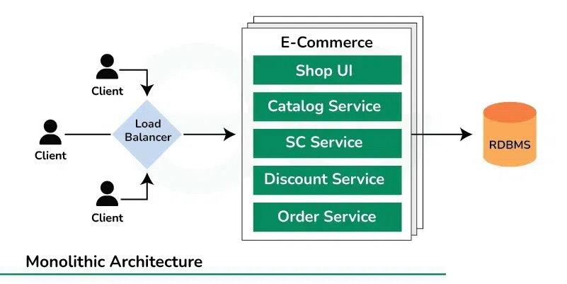

**Importance of Monolithic Systems**

Monolithic systems, despite facing increasing competition from more modern architectural styles like microservices, still hold significant importance in various contexts:

* **Simplicity:** Monolithic architectures offer straightforward development and deployment processes. It is frequently simpler for developers to understand the system as a whole and make modifications when all the components are packed together.
* **Cost-Effectiveness:** Monolithic architectures can be more economical for startups or small to medium-sized projects. Compared to distributed systems, they require simpler deployment settings and less infrastructure overhead.
* **Performance:** Because everything is operating within the same process, monolithic systems can occasionally offer higher performance because there is less communication overhead between components.
* **Security:** With fewer inter-service communication points, monolithic systems may have a reduced attack surface, making them potentially more secure, especially if proper security measures are implemented.
* **Legacy Support:**Many existing systems still rely on monolithic architectures. Maintaining and evolving these systems requires expertise, and understanding monolithic architectures is crucial for their continued operation.

**Characteristics of Monolithic Architecture**

Monolithic architecture exhibits several defining characteristics:

* **Single Codebase:**The program is simpler to manage and implement since all of its components are created and maintained in a single codebase.
* **Tight Coupling:** The architecture's components are closely linked, rely on one another, and frequently exchange resources and data directly.
* **Shared Memory:**Monolithic applications typically share the same memory space, allowing components to communicate efficiently without the need for network overhead.
* **Centralized Database:**Data storage is centralized within the application, typically using a single database instance for all data storage needs.
* **Layered Structure:**The structure of monolithic systems is frequently layered, with separate layers for data access, business logic, and presentation. This might result in dependencies across layers even while it separates issues.
* **Limited**[**Scalability**](https://www.geeksforgeeks.org/what-is-scalability-and-how-to-achieve-it-learn-system-design/)**:** Because the entire application must be scaled at once, scaling a monolithic application can be difficult and frequently leads to inefficiencies and higher resource usage.

**Key Components of Monolithic Architecture**

The key components of a monolithic architecture are:

1. **User Interface (UI):** This component is responsible for providing users with information and gathering feedback through the use of buttons, forms, and other interactive elements.
2. **Application Logic:**This part, which is sometimes referred to as the business logic layer, contains the application's main functionality. It manipulates data, processes user interface requests, and carries out any computations or actions that are required.
3. **Data Access Layer:** Interactions with the database or other data storage systems are managed by this component. It guarantees that the program may retrieve and alter data as required by providing functions for querying, inserting, updating, and deleting data.
4. **Database:**The database stores the application's data in a structured format. It can be relational, NoSQL, or another type of database, depending on the requirements of the application.
5. **External Dependencies:**Additionally, monolithic apps may communicate with third-party APIs, authentication providers, or messaging queues, among other external systems or services. Additional functionality or system integration is made possible by these dependencies.
6. **Middleware:**In certain instances, middleware components that manage cross-cutting issues like logging, security, or performance monitoring or help with communication between various application components may be included in monolithic systems.

**Design Principles of Monolithic Systems**

Monolithic system design focuses on preserving manageability, consistency, and simplicity within a single codebase. Some of the key design principles are:

* **Modularity:** Even though a monolithic system consists of a single codebase, it's essential to structure the code in a modular way.
* **Separation of Concerns:** According to the separation of concerns principle, several application components should be responsible for separate tasks. For instance, debugging is made easier and code organization is made clearer by separating the user interface logic from business and data access logic.
* [**Scalability**](https://www.geeksforgeeks.org/what-is-scalability/)**:**Architecting the system to support horizontal scaling when necessary is known as "scalability design." This might involve introducing asynchronous processing for resource-intensive operations, employing caching methods, or optimizing performance-critical components.
* **Encapsulation:**Encapsulation is the process of revealing only the interfaces that are required for interaction while hiding the core operations of a component. Developers can reduce dependencies and make code maintenance and evolution easier by encapsulating functionality within clearly defined interfaces.
* [**Consistency**](https://www.geeksforgeeks.org/consistency-in-system-design/)**:**Maintaining consistency in coding styles, architectural patterns, and design principles across the entire codebase ensures clarity and predictability for developers.

**Challenges in deploying Monolithic Architecture**

Monolithic architecture deployment presents a number of difficulties, such as:

* **Long Deployment Cycles:**
  + When a monolithic application is deployed, the complete codebase is usually deployed as a single unit.
  + Because every component of the program must be packaged, tested, and deployed simultaneously, this may lead to longer deployment times.
* **Risk of Downtime:**
  + Deploying a monolithic application may require taking the entire system offline temporarily, especially if the deployment involves making significant changes or updates.
  + This downtime can impact user experience and business operations.
* **Limited Scalability:**
  + Because scaling typically involves replicating the complete application stack, scaling a monolithic application can be difficult.
  + This can result in inefficiencies and higher infrastructure expenses, especially when demand is high.
* **Resource Consumption:**
  + Compared to more lightweight architectures like microservices, monolithic programs may use more memory and CPU.
  + This may result in decreased overall efficiency and increased infrastructure expenses.
* **Limited Flexibility:**
  + Compared to architectures with separated components, it can be more difficult to make modifications to a monolithic application.
  + Modifications may require altering several areas of the codebase, which raises the possibility of adding errors or inconsistencies.

**Scaling Monolithic Systems**

Scaling monolithic systems can be challenging due to their inherent design, but several strategies can help alleviate these challenges:

* [**Vertical scaling**](https://www.geeksforgeeks.org/system-design-horizontal-and-vertical-scaling/)**:** Also known as scale-up, this involves increasing existing server or virtual machine resources (such as CPU, memory, or storage) when running a monolithic application Although this approach can provide immediate relief though it has limitations, beyond which it is prohibitively expensive or potentially impractical.
* **Performance Optimization:**Identifying and optimizing operational bottlenecks in single-function operations. This might involve profiling the application to find areas of inefficiency, optimizing database queries, improving algorithmic complexity, or reducing unnecessary resource usage
* [**Caching**](https://www.geeksforgeeks.org/caching-system-design-concept-for-beginners/)**:** Strengthen caching options to reduce the load on external services. By saving frequently accessed data or statistical results, you can reduce the strain on the application and improve response time. However, storage methods must be carefully configured to ensure accuracy and up-to-date information.
* [**Load Balancing**](https://www.geeksforgeeks.org/what-is-load-balancer-system-design/)**:** Use load balancing to distribute incoming traffic across multiple instances of a monolithic application. This can help divide the work more evenly and improve scalability.
* [**Database sharding**](https://www.geeksforgeeks.org/database-sharding-a-system-design-concept/): If the database is a bottleneck, consider sharding the database to share data across multiple database instances. Each shard stores a small portion of the data, allowing for horizontal scaling of the database. However, database sharding adds complexity to the application and requires careful planning and maintenance.

**Strategies for Migrating from Monolithic Architecture to Microservices**

The process of migration from a monolithic to a microservices architecture is complex and calls for careful planning and implementation. The following are some typical migration tactics:

**1.**[**Strangler Fig Pattern**](https://www.geeksforgeeks.org/strangler-pattern-in-micro-services-system-design/)

This approach involves gradually substituting microservices for portions of the monolithic application. While old functionality is progressively refactored and migrated, new features and functionalities are implemented as microservices. This method enables a gradual transfer without interfering with the application's current functioning.

**2. Decomposition by Business Capability**

Determine the monolithic application and break it up into microservices according to domains or business capabilities. Every microservice is in charge of a particular feature or business function, including payment processing, product catalog management, or user management. This method allows teams to concentrate on particular business areas and is in line with domain-driven design concepts.

**3. Database Decoupling**

The database schema and the application code are closely related in many monolithic applications. Migrating to microservices can be made easier by decoupling the database through the use of database-per-service patterns or service-specific databases. This eliminates dependencies and permits independent development and deployment by letting each microservice to have its own database schema.

**4.**[**Event-Driven Architecture**](https://www.geeksforgeeks.org/event-driven-architecture-system-design/)

Adopt an event-driven architecture to enable asynchronous communication and decouple microservices. Events can be used to trigger actions and propagate changes between microservices, reducing dependencies and improving scalability and resilience.